PRACTICAL – 5
Implement a producer-consumer communication system using anonymous pipes where the parent process generates data and the child process consumes it. Measure the communication efficiency.
Develop a program that executes the equivalent of the shell command: ls -l | grep ".c" using fork(), pipe(), dup2(), and exec() system calls.

#include <stdio.h>
#include <stdlib.h>
#include <unistd.h>
#include <sys/wait.h>

int main() {
int fd[2];
pid_t pid1, pid2;

if (pipe(fd) == -1) {
perror("pipe");
return 1;
}

// First child: execute ls -l
pid1 = fork();

if (pid1 < 0) {
perror("fork");
return 1;
}

if (pid1 == 0) {
close(fd[0]);

dup2(fd[1], STDOUT_FILENO);
close(fd[1]);

execlp("ls", "ls", "-l", (char *)NULL);

perror("exec ls");
exit(1);
}

// Second child: execute grep .c
pid2 = fork();

if (pid2 < 0) {
perror("fork");
close(fd[0]);
close(fd[1]);
waitpid(pid1, NULL, 0);
return 1;
}

if (pid2 == 0) {
close(fd[1]);

dup2(fd[0], STDIN_FILENO);
close(fd[0]);

execlp("grep", "grep", ".c", (char *)NULL);

perror("exec grep");
exit(1);
}

// Parent does not use the pipe
close(fd[0]);
close(fd[1]);

// Wait for both children
waitpid(pid1, NULL, 0);
waitpid(pid2, NULL, 0);

return 0;
}
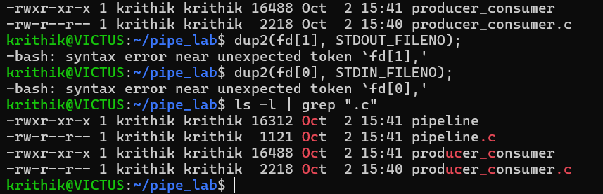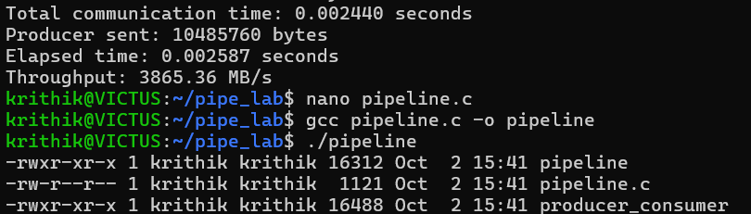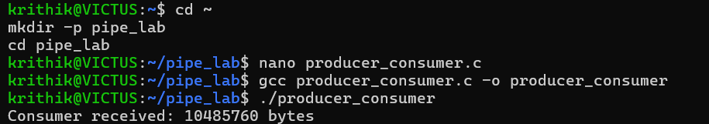synchronization techniques.

